Smart Investment Planner Using ML

# Introduction:

Investing in the stock market can be daunting due to high volatility, complex trends, and an overload of financial data. To simplify the process, we developed an AI-powered Stock Recommendation System that combines deep learning, signal processing and user personalization to forecast stock prices and provide intelligent investment recommendations. This system empowers both novice and experienced investors to make data-driven, customized investment decisions.

Objectives:

* Predict future stock prices using Temporal Convolutional Networks (TCNs).
* Extract meaningful market signals using Hilbert Transform-based decomposition.
* Rank and recommend BSE-listed stocks based on user-defined investment preferences.
* Provide an interactive, real-time dashboard via Streamlit.
* Enable transparent, personalized, and accurate investment insights.

# Explanation of Architecture Diagram:

# Phase 1: Data Acquisition & Processing

# Collect historical stock data using the Alpha Vantage API.

# Decompose price series using Hilbert Transform to extract trends and cycles.

# Phase 2: Forecasting Engine

# Train a Temporal Convolutional Network (TCN) on decomposed signals.

# Predict stock prices over a 30-day horizon.

# Phase 3: Recommendation & User Interaction

# Score stocks based on predicted return, risk, and user profile.

# Display recommendations and visual forecasts via Streamlit UI.

# Architecture Diagram:

# 

# Conclusion:

# The BSE Stock Recommendation System effectively combines deep learning, signal processing, and personalized user inputs to provide accurate stock forecasts and tailored investment recommendations. By leveraging Temporal Convolutional Networks and Hilbert Transform-based decomposition, the system enhances prediction reliability while offering an intuitive interface through Streamlit. This solution simplifies stock analysis, making smart investing accessible to both new and experienced investors.

# Methodology:

# Data collection:

# Fetch historical stock data (top 50 BSE companies) using Alpha Vantage API

# Signal Decomposition:

# Apply moving average smoothing and Hilbert Transform to extract amplitude and phase components.

# Forecasting with TCN:

# Train a TCN model using PyTorch to forecast 30-day stock trends.

# Personalized Recommendation:

# Match forecasted stocks with user preferences (risk, strategy, budget).

# Rank top 5 stocks using a custom scoring function.

# User Interface

# Streamlit dashboard for easy interaction, stock selection, and real-time visualization.

# Results:

# 

|  |  |  |  |  |
| --- | --- | --- | --- | --- |
| Symbol | Current Price | Predicted Price | Return % | Qty Possible |
| SBIN | ₹769.0 | ₹1237.20 | 60.88% | 65 |
| JWSSTEEL | ₹953.20 | ₹1475.28 | 54.77% | 52 |
| HDFCBANK | ₹1928.5 | ₹2882.2 | 49.45% | 25 |
| BHARTIARTL | ₹1874.9 | ₹2780.19 | 48.28% | 26 |
| COALINDIA | ₹384.45 | ₹559.98 | 45.38% | 129 |

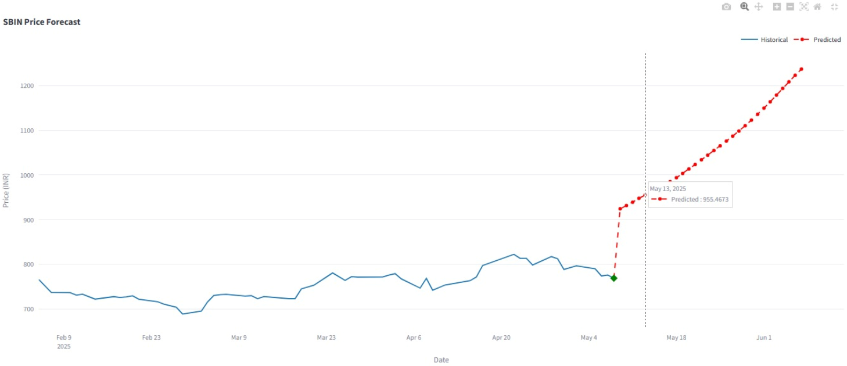

**Team No. 10**

**Team Member Details:**

Abhinav Unnamatla (22241A6767)

Amit Jasti (22241A6793)

Medhansh Kotipalli (22241A6799)

**Name of the Guide:**

Dr. M. Kiran Kumar,

Associate Professor, Department of Data Science